***This is a bonus Web chapter

CHAPTER 48

Red-Black Trees

Objectives
- To know what a red-black tree is (§48.1).
- To convert a red-black tree to a 2-4 tree and vice versa (§48.2).
- To design the RBTree class that extends the BinaryTree class (§48.3).
- To insert an element in a red-black tree and resolve the double-red violation if necessary (§48.4).
- To delete an element from a red-black tree and resolve the double-black problem if necessary (§48.5).
- To implement and test the RBTree class (§§48.6–48.7).
- To compare the performance of AVL trees, 2-4 trees, and RBTree (§48.8).

48.1 Introduction
<margin note: derived from 2-4>
<margin note: color attribute>
<margin note: external>
<margin note: black depth>
A red-black tree is a binary search tree derived from a 2-4 tree. A red-black tree corresponds to a 2-4 tree. Each node in a red-black tree has a color attribute red or black, as shown in Figure 48.1(a). A node is called external if its left or right subtree is empty. Note that a leaf node is external, but an external node is not necessarily a leaf node. For example, node 25 is external, but it is not a leaf. The black depth of a node is defined as the number of black nodes in a path from the node to the root. For example, the black depth of node 25 is 2 and that of node 27 is 2.

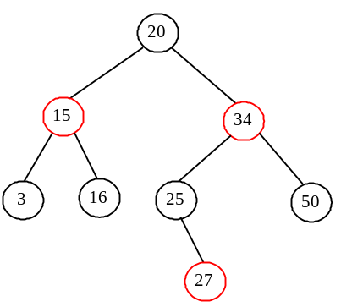 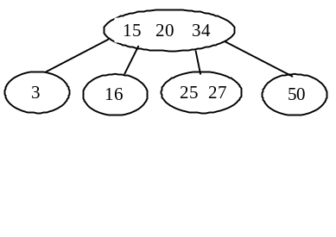
(a) A red-black tree (b) A 2-4 tree

Figure 48.1
A red-black tree can be represented using a 2-4 tree, and vice versa.

NOTE: The red nodes appear in blue in the text.
A red-black tree has the following properties:

- The root is black.
- Two adjacent nodes cannot be both red.
- All external nodes have the same black depth.

The red-black tree in Figure 48.1(a) satisfies all three properties. A red-black tree can be converted to a 2-4 tree, and vice versa. Figure 48.1(b) shows an equivalent 2-4 tree for the red-black tree in Figure 48.1(a).

48.2 Conversion between Red-Black Trees and 2-4 Trees

You can design insertion and deletion algorithms for red-black trees without having knowledge of 2-4 trees. However, the correspondence between red-black trees and 2-4 trees provides useful intuition about the structure of red-black trees and operations. For this reason, this section discusses the correspondence between these two types of trees.

<margin note: red-black to 2-4>
To convert a red-black tree to a 2-4 tree, simply merge every red node with its parent to create a 3-node or a 4-node. For example, the red nodes 15 and 34 are merged to their parent to create a 4-node, and the red node 27 is merged to its parent to create a 3-node, as shown in Figure 48.1(b).

<margin note: 2-4 to red-black>
To convert a 2-4 tree to a red-black tree, perform the following transformations for each node :

<margin note: converting 2-node>
- If is a 2-node, color it black, as shown in Figure 48.2(a).
<margin note: converting 3-node>
- If is a 3-node with element values and , there are two ways to convert it. Either make the parent of or make the parent of . In any case, color the parent black and the child red, as shown in Figure 48.2(b).
<margin note: converting 4-node>
- If is a 4-node with element values , , and 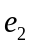, make the parent of and . Color black and and red, as shown in Figure 48.2(c).

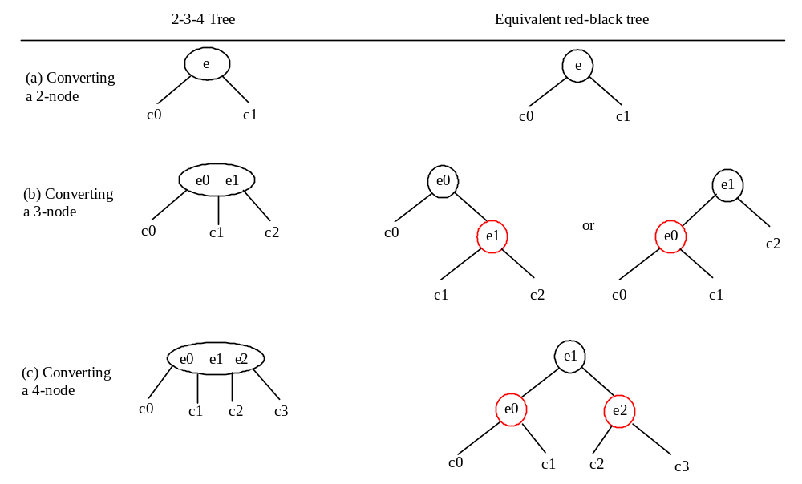

Figure 48.2
A node in a 2-4 tree can be transformed to nodes in a red-black tree.

<margin note: not unique>
Let us apply the transformation for the 2-4 tree in Figure 48.1(b). After transforming the 4-node, the tree is as shown in Figure 48.3(a). After transforming the 3-node, the tree is as shown in Figure 48.3(b). Note that the transformation for a 3-node is not unique. Therefore, the conversion from a 2-4 tree to a red-black tree is not unique. After transforming the 3-node, the tree could also be as shown in Figure 48.3(c).

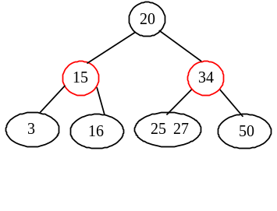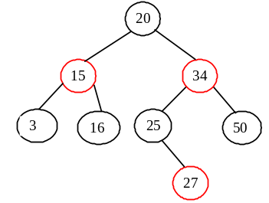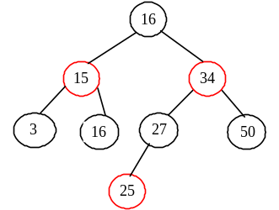
(a) (b) (c)

Figure 48.3
The conversion from a 2-4 tree to a red-black tree is not unique.

You can prove that the conversion results in a red-black tree that satisfies all three properties.

<margin note: Property 1 proof>
Property 1. The root is black.
Proof: If the root of a 2-4 tree is a 2-node, the root of the red-black tree is black. If the root of a 2-4 tree is a 3-node or 4-node, the transformation produces a black parent at the root.

<margin note: Property 2 proof>
Property 2. Two adjacent nodes cannot be both red.
Proof: Since the parent of a red node is always black, no two adjacent nodes can be both red.

<margin note: Property 3 proof>
Property 3. All external nodes have the same black depth.
Proof: When you covert a node in a 2-4 tree to red-black tree nodes, you get one black node and zero, one, or two red nodes as its children, depending on whether the original node is a 2-, 3-, or 4-node. Only a leaf 2-4 node may produce external red-black nodes. Since a 2-4 tree is perfectly balanced, the number of black nodes in any path from the root to an external node is the same.

48.3 Designing Classes for Red-Black Trees

A red-black tree is a binary search tree. So, you can define the RBTree class to extend the BinaryTree class, as shown in Figure 48.4. The BinaryTree and TreeNode classes are defined in §26.2.5.

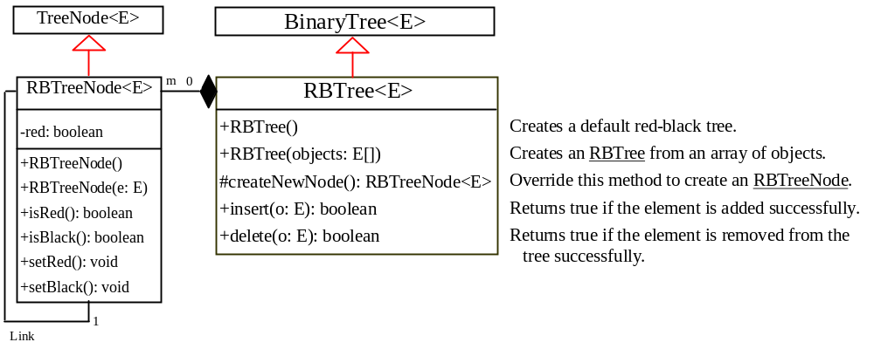

Figure 48.4
The RBTree class extends BinaryTree with new implementations for the insert and delete methods.

<margin note: RBTreeNode>
Each node in a red-black tree has a color property. Because the color is either red or black, it is efficient to use the boolean type to denote it. The RBTreeNode class can be defined to extend BinaryTree.TreeNode with the color property. For convenience, we also provide the methods for checking the color and setting a new color. Note that TreeNode is defined as a static inner class in BinaryTree. RBTreeNode will be defined as a static inner class in RBTree. Note that BinaryTreeNode contains the data fields element, left, and right, which are inherited in RBTreeNode. So, RBTreeNode contains four data fields, as pictured in Figure 48.5.

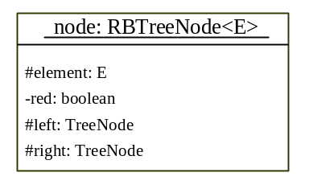

Figure 48.5
An RBTreeNode contains data fields element, red, left, and right.

<margin note: createNewNode()>
In the BinaryTree class, the createNewNode() method creates a TreeNode object. This method is overridden in the RBTree class to create an RBTreeNode. Note that the return type of the createNewNode() method in the BinaryTree class is TreeNode, but the return type of the createNewNode() method in RBTree class is RBTreeNode. This is fine, since RBTreeNode is a subtype of TreeNode.

Searching an element in a red-black tree is the same as searching in a regular binary search tree. So, the search method defined in the BinaryTree class also works for RBTree.

The insert and delete methods are overridden to insert and delete an element and perform operations for coloring and restructuring if necessary to ensure that the three properties of the red-black tree are satisfied.

Pedagogical NOTE
<side remark: Red-Black tree animation>
Run from www.cs.armstrong.edu/liang/animation/RBTreeAnimation.html to see how a red-black tree works, as shown in Figure 48.6.

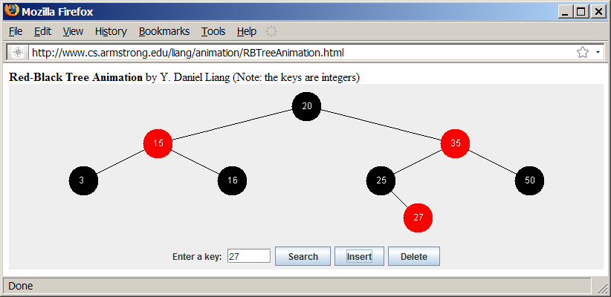

Figure 48.6

The animation tool enables you to insert, delete, and search elements in a red-black tree visually.
***End NOTE

48.4 Overriding the insert Method
<margin note: double red>
A new element is always inserted as a leaf node. If the new node is the root, color it black. Otherwise, color it red. If the parent of the new node is red, it violates Property 2 of the red-black tree. We call this a double-red violation.

Let denote the new node inserted, the parent of , the parent of , and the sibling of . To fix the double-red violation, consider two cases:

Case 1: is black or is null. There are four possible configurations for , , , and , as shown in Figures 48.7(a), 48.8(a), 48.9(a), and 48.10(a). In this case, , , and form a 4-node in the corresponding 2-4 tree, as shown in Figures 48.7(c), 48.8(c), 48.9(c), and 48.10(c), but are represented incorrectly in the red-black tree. To correct this error, restructure and recolor three nodes , , and , as shown in Figures 48.7(b), 48.8(b), 48.9(b), and 48.10(b). Note that , 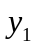, 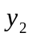, and 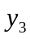 may be null.

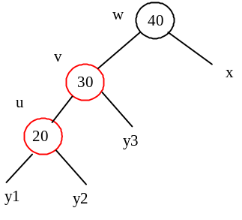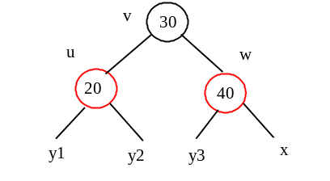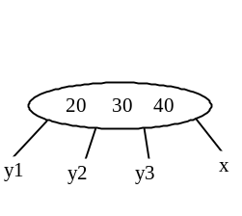
(a) (b) (c)

Figure 48.7
Case 1.1: u < v < w.

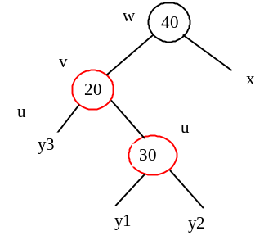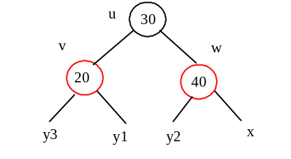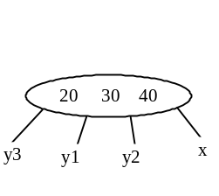
(a) (b) (c)

Figure 48.8
Case 1.2: v < u < w

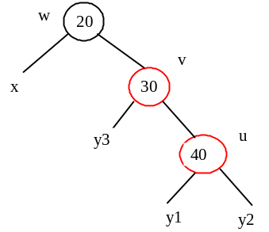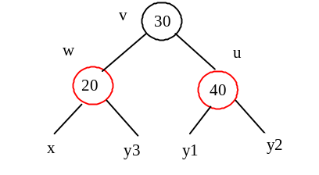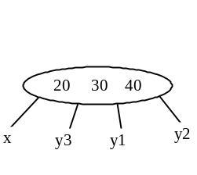
(a) (b) (c)

Figure 48.9
Case 1.3: w < v < u

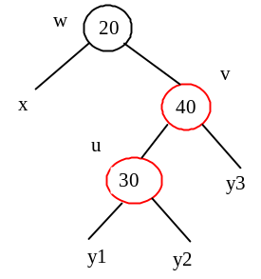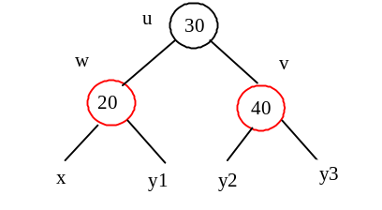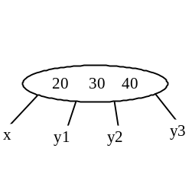
(a) (b) (c)

Figure 48.10
Case 1.4: w < u < v

Case 2: is red. There are four possible configurations for , , , and , as shown in Figures 48.11(a), 48.11(b), 48.11(c), and 48.11(d). All of these configurations correspond to an overflow situation in the corresponding 4-node in a 2-4 tree, as shown in Figure 48.12(a). A splitting operation is performed to fix the overflow problem in a 2-4 tree, as shown in Figure 48.12(b). We perform an equivalent recoloring operation to fix the problem in a red-black tree. Color and red and color two children of black. Assume is a left child of , as shown in Figure 48.11(a). After recoloring, the nodes are shown in Figure 48.12(c). Now is red, if ’s parent is black, the double-red violation is fixed. Otherwise, a new double-red violation occurs at node . We need to continue the same process to eliminate the double-red violation at , recursively.

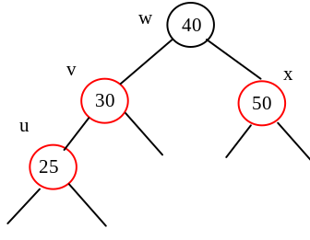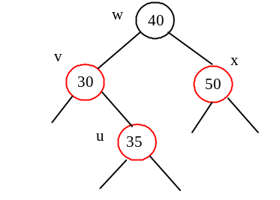
(a) (b)

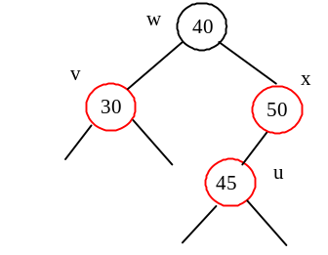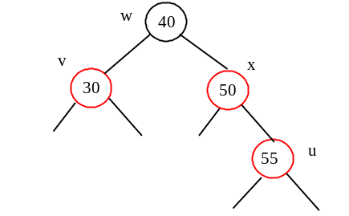
(c) (d)

Figure 48.11
Case 2 has four possible configurations.

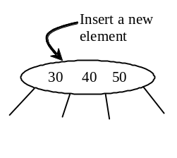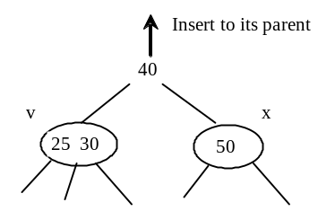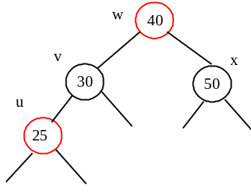
(a) A 4-node (b) Splitting a 4-node (c) Recoloring nodes

Figure 48.12
Splitting a 4-node corresponds to recoloring the nodes in the red-black tree.

A more detailed algorithm for inserting an element is described in Listing 48.1.

Listing 48.1 Inserting an Element to a Red-Black Tree

<margin note line 1: insert to tree>
<margin note line 2: invoke super.insert>
<margin note line 4: duplicate element>
<margin note line 6: ensure color and depth>

<margin note line 13: ensure color and depth>
<margin note line 14: get path>
<margin note line 15: node index>
<margin note line 16: get u, v>
<margin note line 20: u is root?>
<margin note line 22: double-red violation>

<margin note line 27: fix double red>
<margin note line 29: get w>
<margin note line 32: get x>
<margin note line 36: Case 1>
<margin note line 38: Case 1.1>
<margin note line 41: Case 1.2>
<margin note line 44: Case 1.3>
<margin note line 47: Case 1.4>
<margin note line 50: Case 2>
<margin note line 51: recoloring>
<margin note line 54: w is root?>
<margin note line 57: propagate upward>
<margin note line 61: fix new double red>

public boolean insert(E e) {
boolean successful = super.insert(e);
if (!successful)
return false; // e is already in the tree
else {
ensureRBTree(e);
}

return true; // e is inserted
}

/** Ensure that the tree is a red-black tree */
private void ensureRBTree(E e) {
Get the path that leads to element e from the root.
int i = path.size() – 1; // Index to the current node in the path
Get u, v from the path. u is the node that contains e and v
is the parent of u.
Color u red;

if (u == root) // If e is inserted as the root, set root black
u.setBlack();
else if (v.isRed())
fixDoubleRed(u, v, path, i); // Fix double-red violation at u
}

/** Fix double-red violation at node u */
private void fixDoubleRed(RBTreeNode<E> u, RBTreeNode<E> v,
ArrayList<TreeNode<E>> path, int i) {
Get w from the path. w is the grandparent of u.

// Get v's sibling named x
RBTreeNode<E> x = (w.left == v) ?
(RBTreeNode<E>)(w.right) : (RBTreeNode<E>)(w.left);

if (x == null || x.isBlack()) {
// Case 1: v's sibling x is black
if (w.left == v && v.left == u) {
// Case 1.1: u < v < w, Restructure and recolor nodes
}
else if (w.left == v && v.right == u) {
// Case 1.2: v < u < w, Restructure and recolor nodes
}
else if (w.right == v && v.right == u) {
// Case 1.3: w < v < u, Restructure and recolor nodes
}
else {
// Case 1.4: w < u < v, Restructure and recolor nodes
}
}
else { // Case 2: v's sibling x is red
Color w and u red
Color two children of w black.

if (w is root) {
Set w black;
}
else if (the parent of w is red) {
// Propagate along the path to fix new double-red violation
u = w;
v = parent of w;
fixDoubleRed(u, v, path, i - 2); // i – 2 propagates upward
}
}
}

<margin note: insert(E, e)>
The insert(E e) method (lines 1–10) invokes the insert method in the BinaryTree class to create a new leaf node for the element (line 2). If the element is already in the tree, return false (line 4). Otherwise, invoke ensureRBTree(e) (line 6) to ensure that the tree satisfies the color and black depth property of the red-black tree.

<margin note: ensureRBTree(E, e)>
The ensureRBTree(E e) method (lines 13–24) obtains the path that leads to e from the root (line 14), as shown in Figure 48.13. This path plays an important role to implement the algorithm. From this path, you get nodes u and v (lines 16–17). If u is the root, color u black (lines 20–21). If v is red, a double-red violation occurs at node u. Invoke fixDoubleRed to fix the problem.

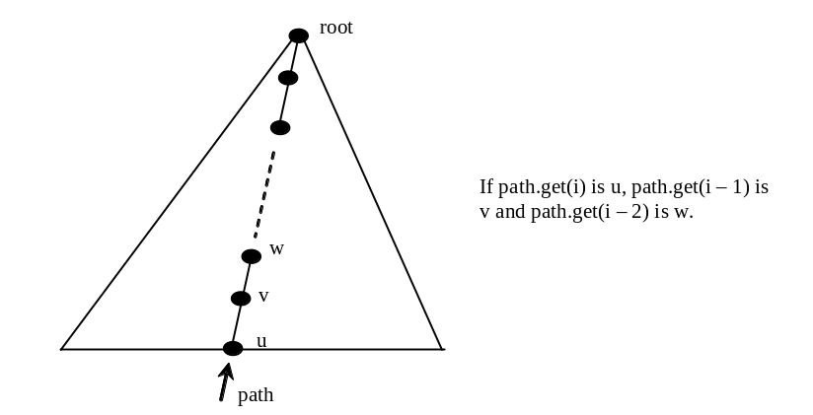

Figure 48.13
The path consists of the nodes from u to the root.

<margin note: fixDoubleRed>
The fixDoubleRed method (lines 27–63) fixes the double-red violation. It first obtains w (the parent of v) from the path (line 29) and x (the sibling of v) (lines 32–33). If x is empty or a black node, restructure and recolor three nodes u, v, and w to eliminate the problem (lines 35–49). If x is a red node, recolor the nodes u, v, w and x (lines 51–52). If w is the root, color w black (lines 54–56). If the parent of w is red, the double-red violation reappears at w. Invoke fixDoubleRed with new u and v to fix the problem (line 61). Note that now i – 2 points to the new u in the path. This adjustment is necessary to locate the new nodes w and parent of w along the path.

<margin note: insertion example>
Figure 48.14 shows the steps of inserting 34, 3, 50, 20, 15, 16, 25, and 27 into an empty red-black tree. When inserting 20 into the tree in (d), Case 2 applies to recolor 3 and 50 to black. When inserting 15 into the tree in (g), Case 1.4 applies to restructure and recolor nodes 15, 20, and 3. When inserting 16 into the tree in (i), Case 2 applies to recolor nodes 3 and 20 to black and nodes 15 and 16 to red. When inserting 27 into the tree in (l), Case 2 applies to recolor nodes 16 and 25 to black and nodes 20 and 27 to red. Now a new double-red problem occurs at node 20. Apply Case 1.2 to restructure and recolor nodes. The new tree is shown in (n).

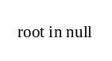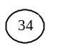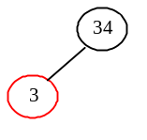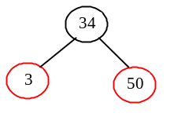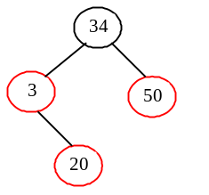
(a) (b) (c) (d) (e)

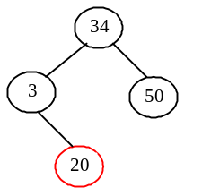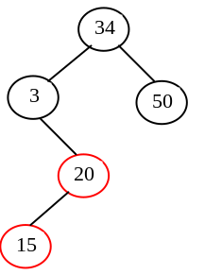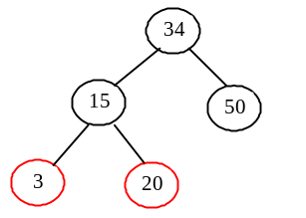

(f) (g) (h)

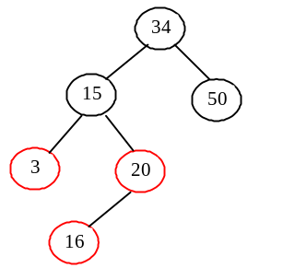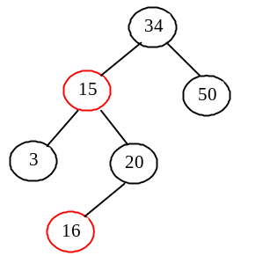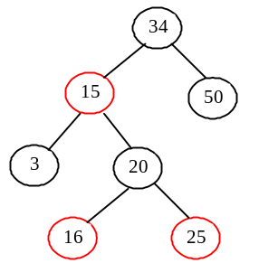

(i) (j) (k)

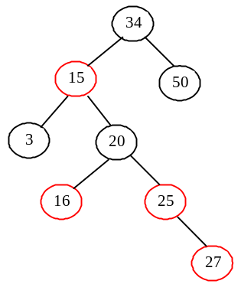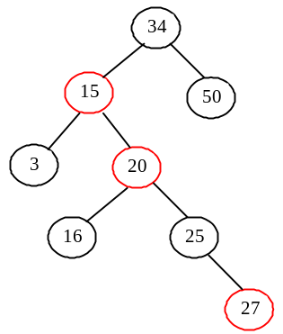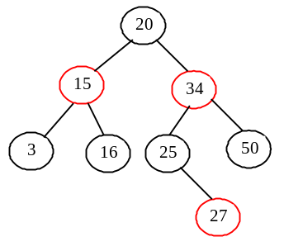
(l) (m) (n)

Figure 48.14
Inserting into a red-black tree: (a) initial empty tree; (b) inserting 34; (c) inserting 3; (d) inserting 50; (e) inserting 20 causes a double red; (f) after recoloring (Case 2); (g) inserting 15 causes a double red; (h) after restructuring and recoloring (Case 1.4); (i) inserting 16 causes a double red; (j) after recoloring (Case 2); (k) inserting 25; (l) inserting 27 causes a double red at 27; (m) a double red at 20 reappears after recoloring (Case 2); (n) after restructuring and recoloring (Case 1.2).

48.5 Overriding the delete Method
To delete an element from a red-black tree, first search the element in the tree to locate the node that contains the element. If the element is not in the tree, the method returns false. Let be the node that contains the element. If is an internal node with both left and right children, find the rightmost node in the left subtree of . Replace the element in with the element in the rightmost node. Now we will only consider deleting external nodes.

Let be an external node to be deleted. Since is an external node, it has at most one child, denoted by 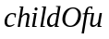. may be null. Let 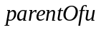 denote the parent of , as shown in Figure 48.15(a). Delete by connecting with , as shown in Figure 48.15(b).

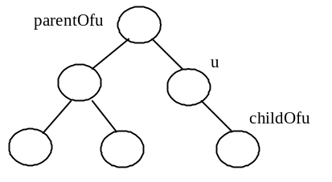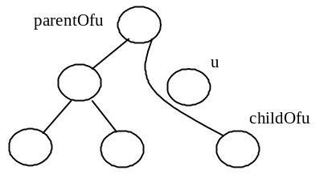

(a) Before deleting u (b) After deleting u

Figure 48.15
u is an external node and childOfu may be null.

Consider the following case:

- If is red, we are done.
- If is black and is red, color black to maintain the black height for .
<margin note: double black>
- Otherwise, assign a fictitious double black, as shown in Figure 48.16(a). We call this a double-black problem, which indicates that the black-depth is short by 1, caused by deleting a black node u.

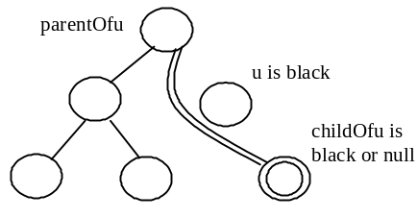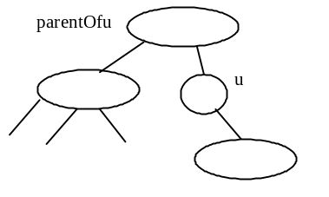

(a) (b)

Figure 48.16
(a) childOfu is denoted double black. (b) u corresponds to an empty node in a 2-4 tree.

A double black in a red-black tree corresponds to an empty node for u (i.e., underflow situation) in the corresponding 2-4 tree, as shown in Figure 48.16(b). To fix the double-black problem, we will perform equivalent transfer and fusion operations. Consider three cases:

<margin note: Case 1>
Case 1: The sibling y of is black and has a red child. This case has four possible configurations, as shown in Figures 48.17(a), 48.18(a), 48.19(a), and 48.20(a). The dashed circle denotes that the node is either red or black. To eliminate the double-black problem, restructure and recolor the nodes, as shown in Figures 48.17(b), 48.18(b), 48.19(b), and 48.20(b).
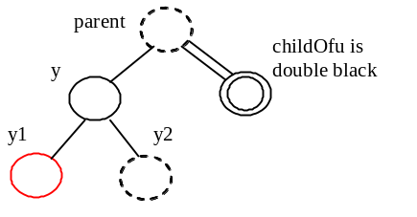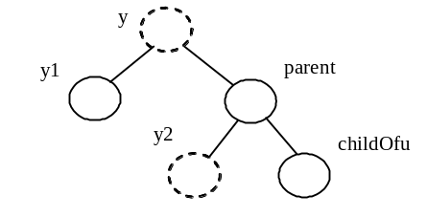

(a) (b)

Figure 48.17
Case 1.1: The sibling y of childOfu is black and y1 is red.

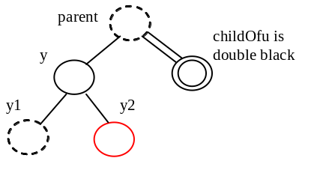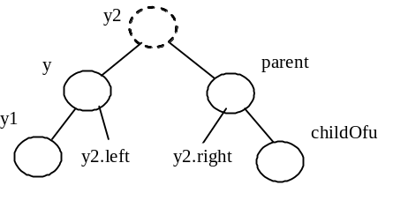

(a) (b)

Figure 48.18
Case 1.2: The sibling y of childOfu is black and y2 is red.

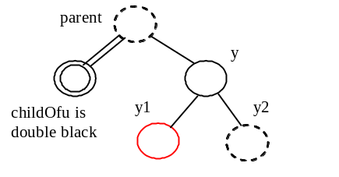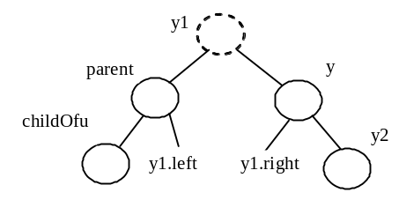

(a) (b)

Figure 48.19
Case 1.3: The sibling y of childOfu is black and y1 is red.

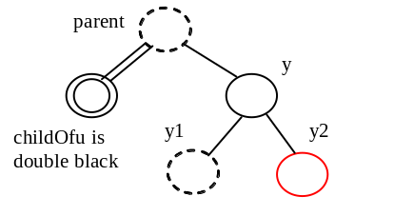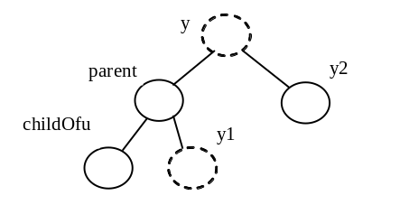

(a) (b)

Figure 48.20
Case 1.4: the sibling y of childOfu is black and y2 is red.

Note
<margin note: transfer operation>
Case 1 corresponds to a transfer operation in the 2-4 tree. For example, the corresponding 2-4 tree for Figure 48.17(a) is shown in Figure 48.21(a), and it is transformed into 48.21(b) through a transfer operation.
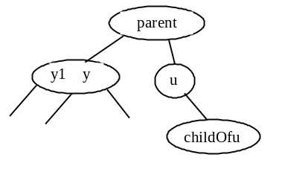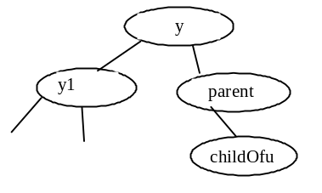

(a) (b)

Figure 48.21
Case 1 corresponds to a transfer operation in the corresponding 2-4 tree.
***END of NOTE

<margin note: Case 2>
<margin note: propagate>
Case 2: The sibling y of is black and its children are black or null. In this case, change y’s color to red. If parent is red, change it to black, and we are done, as shown in Figure 48.22. If parent is black, we denote parent double black, as shown in Figure 48.23. The double-black problem propagates to the parent node.
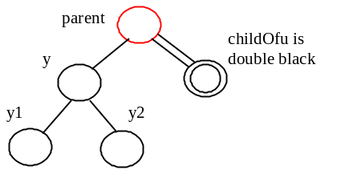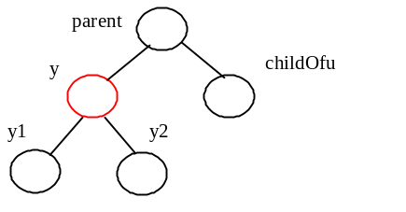

(a) (b)

Figure 48.22
Case 2: Recoloring eliminates the double-black problem if parent is red.

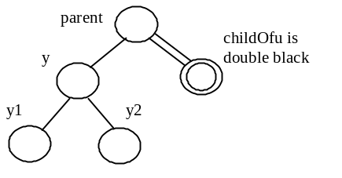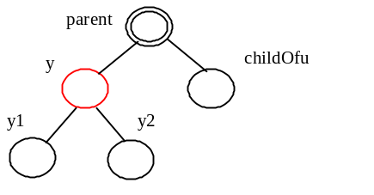

(a) (b)

Figure 48.23
Case 2: Recoloring propagates the double-black problem if parent is black.
Note
<margin note: left childOfu>
Figures 48.22 and 48.22 show that childOfu is a right child of parent. If childOfu is a left child of parent, recoloring is performed identically.
Note
<margin note: fusion operation>
Case 2 corresponds to a fusion operation in the 2-4 tree. For example, the corresponding 2-4 tree for Figure 48.22(a) is shown in Figure 48.24(a), and it is transformed into 48.24(b) through a fusion operation.
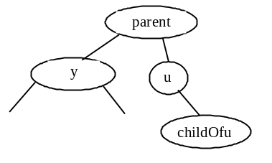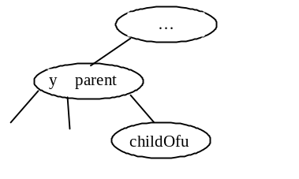

(a) (b)

Figure 48.24
Case 2 corresponds to a fusion operation in the corresponding 2-4 tree.
***END of NOTE

<margin note: Case 3>
<margin note: adjustment>
Case 3: The sibling y of is red. In this case, perform an adjustment operation. If y is a left child of parent, let y1 and y2 be the left and right child of y, as shown in Figure 48.25. If y is a right child of parent, let y1 and y2 be the left and right child of y, as shown in Figure 48.26. In both cases, color y black and parent red. childOfu is still a fictitious double-black node. After the adjustment, the sibling of childOfu is now black, and either Case 1 or Case 2 applies. If Case 1 applies, a one-time restructuring and recoloring operation eliminates the double-black problem. If Case 2 applies, the double-black problem cannot reappear, since parent is now red. Therefore, one-time application of Case 1 or Case 2 will complete Case 3.
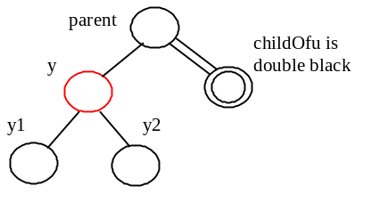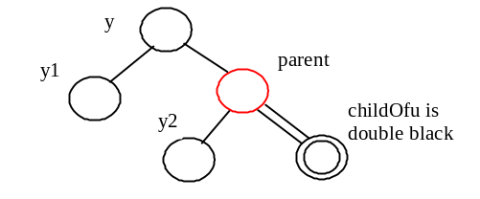

(a) (b)

Figure 48.25
Case 3.1: y is a left red child of parent.
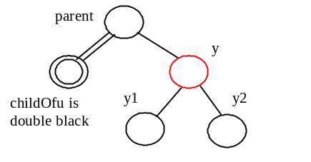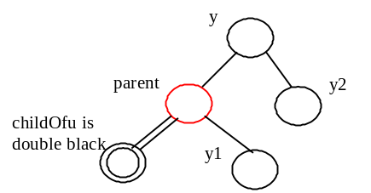

(a) (b)

Figure 48.26
Case 3.2: y is a right red child of parent.

Note
<margin note: nonunique transform of 3-node>
Case 3 results from the fact that a 3-node may be transformed in two ways to a red-black tree, as shown in Figure 48.27.
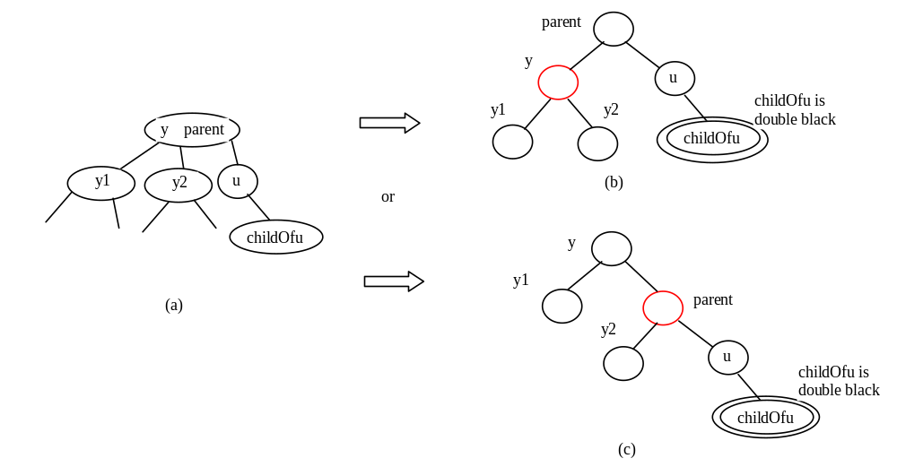

Figure 48.27
A 3-node may be transformed in two ways to red-black tree nodes.
Based on the foregoing discussion, Listing 48.2 presents a more detailed algorithm for deleting an element.

Listing 48.2 Deleting an Element from a Red-Black Tree
<margin note line 1: delete e from tree>
<margin note line 2: locate the node>
<margin note line 4: element not found>
<margin note line 6: internal element?>
<margin note line 7: rightmost node>
<margin note line 12: path to external node>
<margin note line 15: delete the node>
<margin note line 17: one element deleted>
<margin note line 18: deletion successful>

<margin note line 22: delete a node>
<margin note line 23: u>
<margin note line 24: parentOfu, grandparentOfu>
<margin note line 23: childOfu>
<margin note line 26: delete u>
<margin note line 30: done>
<margin note line 32: set childOfu black>
<margin note line 35: fix double black>

<margin note line 39: fix double black>
<margin note line 42: y, y1, y2>
<margin note line 47: process Case 1.1>
<margin note line 51: process Case 1.3>
<margin note line 57: process Case 1.2>
<margin note line 61: process Case 1.4>
<margin note line 66: process Case 2>
<margin note line 77: propagate double black>
<margin note line 83: process Case 3.1>
<margin note line 88: process Case 3.2>
<margin note line 95: fix double black>

public boolean delete(E e) {
Locate the node to be deleted
if (the node is not found)
return false;

if (the node is an internal node) {
Find the rightmost node in the subtree of the node;
Replace the element in the node with the one in rightmost;
The rightmost node is the node to be deleted now;
}

Obtain the path from the root to the node to be deleted;

// Delete the last node in the path and propagate if needed
deleteLastNodeInPath(path);

size--; // After one element deleted
return true; // Element deleted
}

/** Delete the last node from the path. */
public void deleteLastNodeInPath(ArrayList<TreeNode<E>> path) {
Get the last node u in the path;
Get parentOfu and grandparentOfu in the path;
Get childOfu from u;
Delete node u. Connect childOfu with parentOfu

// Recolor the nodes and fix double black if needed
if (childOfu == root || u.isRed())
return; // Done if childOfu is root or if u is red
else if (childOfu != null && childOfu.isRed())
childOfu.setBlack(); // Set it black, done
else // u is black, childOfu is null or black
// Fix double black on parentOfu
fixDoubleBlack(grandparentOfu, parentOfu, childOfu, path, i);
}

/** Fix the double black problem at node parent */
private void fixDoubleBlack(
RBTreeNode<E> grandparent, RBTreeNode<E> parent,
RBTreeNode<E> db, ArrayList<TreeNode<E>> path, int i) {
Obtain y, y1, and y2

if (y.isBlack() && y1 != null && y1.isRed()) {
if (parent.right == db) {
// Case 1.1: y is a left black sibling and y1 is red
Restructure and recolor parent, y, and y1 to fix the problem;
}
else {
// Case 1.3: y is a right black sibling and y1 is red
Restructure and recolor parent, y1, and y to fix the problem;
}
}
else if (y.isBlack() && y2 != null && y2.isRed()) {
if (parent.right == db) {
// Case 1.2: y is a left black sibling and y2 is red
Restructure and recolor parent, y2, and y to fix the problem;
}
else {
// Case 1.4: y is a right black sibling and y2 is red
Restructure and recolor parent, y, and y2 to fix the problem;
}
}
else if (y.isBlack()) {
// Case 2: y is black and y's children are black or null
Recolor y to red;

if (parent.isRed())
parent.setBlack(); // Done
else if (parent != root) {
// Propagate double black to the parent node
// Fix new appearance of double black recursively
db = parent;
parent = grandparent;
grandparent =
(i >= 3) ? (RBTreeNode<E>)(path.get(i - 3)) : null;
fixDoubleBlack(grandparent, parent, db, path, i - 1);
}
}
else if (y.isRed()) {
if (parent.right == db) {
// Case 3.1: y is a left red child of parent
parent.left = y2;
y.right = parent;
}
else {
// Case 3.2: y is a right red child of parent
parent.right = y.left;
y.left = parent;
}

parent.setRed(); // Color parent red
y.setBlack(); // Color y black
connectNewParent(grandparent, parent, y); // y is new parent
fixDoubleBlack(y, parent, db, path, i - 1);
}
}

<margin note: delete(E, e)>
The delete(E e) method (lines 1–19) locates the node that contains e (line 2). If the node does not exist, return false (lines 3–4). If the node is an internal node, find the right most node in its left subtree and replace the element in the node with the element in the right most node (lines 6–9). Now the node to be deleted is an external node. Obtain the path from the root to the node (line 12). Invoke deleteLastNodeInPath(path) to delete the last node in the path and ensure that the tree is still a red-black tree (line 15).

<margin note: deleteLastNodeInPath(path)>
The deleteLastNodeInPath method (lines 22–36) obtains the last node u, parentOfu, grandparendOfu, and childOfu (lines 23–26). If childOfu is the root or u is red, the tree is fine (lines 29–30). If childOfu is red, color it black (lines 31–32). We are done. Otherwise, u is black and childOfu is null or black. Invoke fixDoubleBlack to eliminate the double-black problem (line 35).

<margin note: fixDoubleBlack>
The fixDoubleBlack method (lines 39–97) eliminates the double-black problem. Obtain y, y1, and y2 (line 42). y is the sibling of the double-black node. y1 and y2 are the left and right children of y. Consider three cases:
- If y is black and one of its children is red, the double-black problem can be fixed by one-time restructuring and recoloring in Case 1 (lines 44–63).
- If y is black and its children are null or black, change y to red. If parent of y is black, denote parent to be the new double-black node and invoke fixDoubleBlack recursively (line 77).
- If y is red, adjust the nodes to make parent a child of y (lines 84, 89) and color parent red and y black (lines 92–93). Make y the new parent (line 94). Recursively invoke fixDoubleBlack on the same double-black node with a different color for parent (line 95).

<margin note: deletion example>
Figure 48.28 shows the steps of deleting elements. To delete 50 from the tree in Figure 48.28(a), apply Case 1.2, as shown in Figure 48.28(b). After restructuring and recoloring, the new tree is as shown in Figure 48.28(c).

When deleting 20 in Figure 48.28(c), 20 is an internal node, and it is replaced by 16, as shown in Figure 48.28(d). Now Case 2 applies to deleting the rightmost node, as shown in Figure 48.28(e). Recolor the nodes results in a new tree, as shown in Figure 48.28(f).

When deleting 15, connect node 3 with node 20 and color node 3 black, as shown in Figure 48.28(g). We are done.

After deleting 25, the new tree is as shown in Figure 48.28(j). Now delete 16. Apply Case 2, as shown in Figure 48.28(k). The new tree is shown in Figure 48.28(l).

After deleting 34, the new tree is as shown in Figure 48.28(m).

After deleting 27, the new tree is as shown in Figure 48.28(n).

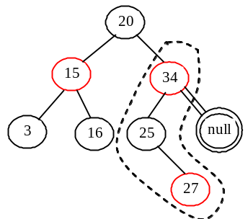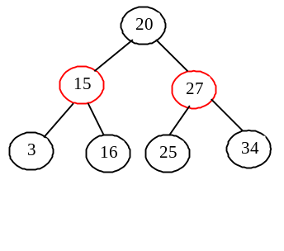
(a) Delete 50 (b) Case 1.2 (c) Delete 20

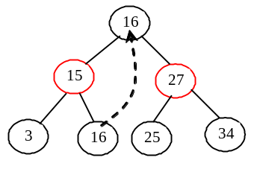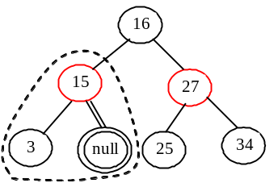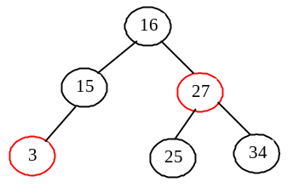
(d) Copy 16 to replace 20 (e) Case 2 (f) Delete 15

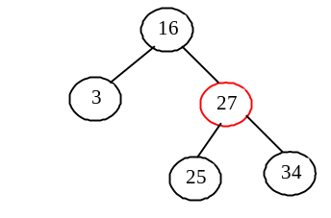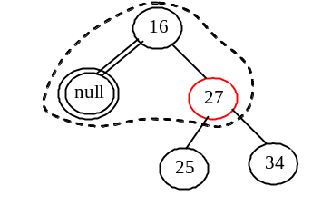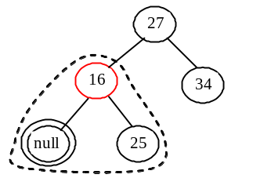
(g) Delete 3 (h) Case 3 (i) Case 2

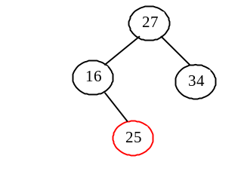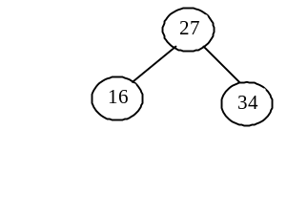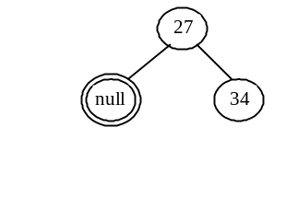
(i) Delete 25 (j) Delete 16 (k) Case 2

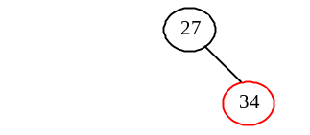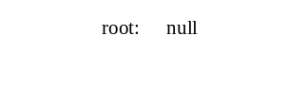

(l) Delete 34 (m) Delete 27 (n) Empty tree

Figure 48.28
Delete elements from a red-black tree.

48.6 Implementing RBTree Class

Listing 48.3 gives a complete implementation for the RBTree class.

Listing 48.3 RBTree.java
<margin note line 5: no-arg constructor>
<margin note line 9: constructor>
<margin note line 14: create a new node>
<margin note line 19: insert to tree>
<margin note line 20: invoke super.insert>
<margin note line 22: duplicate element>
<margin note line 24: ensure color and depth>

<margin note line 31: ensure color and depth>
<margin note line 33: get path>
<margin note line 35: node index>
<margin note line 38: get u >
<margin note line 41: get v>

<margin note line 46: u is root?>
<margin note line 49: double-red violation>

<margin note line 53: fix double red>
<margin note line 56: get w>
<margin note line 61: get x>
<margin note line 65: Case 1>
<margin note line 66: Case 1.1>
<margin note line 73: Case 1.2>
<margin note line 81: Case 1.3>
<margin note line 87: Case 1.4>
<margin note line 96: Case 2>
<margin note line 98: recoloring>
<margin note line 103: w is root?>
<margin note line 108: propagate upward>
<margin note line 110: fix new double red>

<margin note line 116: restructure/recolor>
<margin note line 133: delete e from tree>
<margin note line 135: locate the node>
<margin note line 147: element not found>
<margin note line 153: internal element?>
<margin note line 155: rightmost node>
<margin note line 160: path to external node>
<margin note line 169: delete the node>
<margin note line 171: one element deleted>
<margin note line 172: deletion successful>

<margin note line 176: delete a node>
<margin note line 179: u>
<margin note line 180: parentOfu>
<margin note line 182: grandparentOfu>
<margin note line 185: childOfu>
<margin note line 189: delete u>
<margin note line 193: done>
<margin note line 195: set childOfu black>
<margin note line 198: fix double black>

<margin note line 202: fix double black>
<margin note line 206: y, y1, y2>
<margin note line 212: process Case 1.1>
<margin note line 221: process Case 1.3>
<margin note line 234: process Case 1.2>
<margin note line 245: process Case 1.4>
<margin note line 255: process Case 2>
<margin note line 263: propagate double black>
<margin note line 271: process Case 3.1>
<margin note line 276: process Case 3.2>
<margin note line 285: fix double black>

<margin note line 304: connect to grandParent>
<margin note line 318: override preorder>
<margin note line 327: RBTreeNode>

import java.util.ArrayList;

public class RBTree<E extends Comparable<E>> extends BinaryTree<E> {
/** Create a default RB tree */
public RBTree() {
}

/** Create an RB tree from an array of elements */
public RBTree(E[] elements) {
super(elements);
}

/** Override createNewNode to create an RBTreeNode */
protected RBTreeNode<E> createNewNode(E e) {
return new RBTreeNode<E>(e);
}

/** Override the insert method to balance the tree if necessary */
public boolean insert(E e) {
boolean successful = super.insert(e);
if (!successful)
return false; // e is already in the tree
else {
ensureRBTree(e);
}

return true; // e is inserted
}

/** Ensure that the tree is a red-black tree */
private void ensureRBTree(E e) {
// Get the path that leads to element e from the root
ArrayList<TreeNode<E>> path = path(e);

int i = path.size() - 1; // Index to the current node in the path

// u is the last node in the path. u contains element e
RBTreeNode<E> u = (RBTreeNode<E>)(path.get(i));

// v is the parent of of u, if exists
RBTreeNode<E> v = (u == root) ? null :
(RBTreeNode<E>)(path.get(i - 1));

u.setRed(); // It is OK to set u red

if (u == root) // If e is inserted as the root, set root black
u.setBlack();
else if (v.isRed())
fixDoubleRed(u, v, path, i); // Fix double-red violation at u
}

/** Fix double-red violation at node u */
private void fixDoubleRed(RBTreeNode<E> u, RBTreeNode<E> v,
ArrayList<TreeNode<E>> path, int i) {
// w is the grandparent of u
RBTreeNode<E> w = (RBTreeNode<E>)(path.get(i - 2));
RBTreeNode<E> parentOfw = (w == root) ? null :
(RBTreeNode<E>)path.get(i - 3);

// Get v's sibling named x
RBTreeNode<E> x = (w.left == v) ?
(RBTreeNode<E>)(w.right) : (RBTreeNode<E>)(w.left);

if (x == null || x.isBlack()) {
// Case 1: v's sibling x is black
if (w.left == v && v.left == u) {
// Case 1.1: u < v < w, Restructure and recolor nodes
restructureRecolor(u, v, w, w, parentOfw);

w.left = v.right; // v.right is y3 in Figure 48.6
v.right = w;
}
else if (w.left == v && v.right == u) {
// Case 1.2: v < u < w, Restructure and recolor nodes
restructureRecolor(v, u, w, w, parentOfw);
v.right = u.left;
w.left = u.right;
u.left = v;
u.right = w;
}
else if (w.right == v && v.right == u) {
// Case 1.3: w < v < u, Restructure and recolor nodes
restructureRecolor(w, v, u, w, parentOfw);
w.right = v.left;
v.left = w;
}
else {
// Case 1.4: w < u < v, Restructure and recolor nodes
restructureRecolor(w, u, v, w, parentOfw);
w.right = u.left;
v.left = u.right;
u.left = w;
u.right = v;
}
}
else { // Case 2: v's sibling x is red
// Recolor nodes
w.setRed();
u.setRed();
((RBTreeNode<E>)(w.left)).setBlack();
((RBTreeNode<E>)(w.right)).setBlack();

if (w == root) {
w.setBlack();
}
else if (((RBTreeNode<E>)parentOfw).isRed()) {
// Propagate along the path to fix new double-red violation
u = w;
v = (RBTreeNode<E>)parentOfw;
fixDoubleRed(u, v, path, i - 2); // i – 2 propagates upward
}
}
}

/** Connect b with parentOfw and recolor a, b, c for a < b < c */
private void restructureRecolor(RBTreeNode<E> a, RBTreeNode<E> b,
RBTreeNode<E> c, RBTreeNode<E> w, RBTreeNode<E> parentOfw) {
if (parentOfw == null)
root = b;
else if (parentOfw.left == w)
parentOfw.left = b;
else
parentOfw.right = b;

b.setBlack(); // b becomes the root in the subtree
a.setRed(); // a becomes the left child of b
c.setRed(); // c becomes the right child of b
}

/** Delete an element from the RBTree.
* Return true if the element is deleted successfully
* Return false if the element is not in the tree */
public boolean delete(E e) {
// Locate the node to be deleted
TreeNode<E> current = root;
while (current != null) {
if (e.compareTo(current.element) < 0) {
current = current.left;
}
else if (e.compareTo(current.element) > 0) {
current = current.right;
}
else
break; // Element is in the tree pointed by current
}

if (current == null)
return false; // Element is not in the tree

java.util.ArrayList<TreeNode<E>> path;

// current node is an internal node
if (current.left != null && current.right != null) {
// Locate the rightmost node in the left subtree of current
TreeNode<E> rightMost = current.left;
while (rightMost.right != null) {
rightMost = rightMost.right; // Keep going to the right
}

path = path(rightMost.element); // Get path before replacement

// Replace the element in current by the element in rightMost
current.element = rightMost.element;
}
else
path = path(e); // Get path to current node

// Delete the last node in the path and propagate if needed
deleteLastNodeInPath(path);

size--; // After one element deleted
return true; // Element deleted
}

/** Delete the last node from the path. */
public void deleteLastNodeInPath(ArrayList<TreeNode<E>> path) {
int i = path.size() - 1; // Index to the node in the path
// u is the last node in the path
RBTreeNode<E> u = (RBTreeNode<E>)(path.get(i));
RBTreeNode<E> parentOfu = (u == root) ? null :
(RBTreeNode<E>)(path.get(i - 1));
RBTreeNode<E> grandparentOfu = (parentOfu == null ||
parentOfu == root) ? null :
(RBTreeNode<E>)(path.get(i - 2));
RBTreeNode<E> childOfu = (u.left == null) ?
(RBTreeNode<E>)(u.right) : (RBTreeNode<E>)(u.left);

// Delete node u. Connect childOfu with parentOfu
connectNewParent(parentOfu, u, childOfu);

// Recolor the nodes and fix double black if needed
if (childOfu == root || u.isRed())
return; // Done if childOfu is root or if u is red
else if (childOfu != null && childOfu.isRed())
childOfu.setBlack(); // Set it black, done
else // u is black, childOfu is null or black
// Fix double black on parentOfu
fixDoubleBlack(grandparentOfu, parentOfu, childOfu, path, i);
}

/** Fix the double-black problem at node parent */
private void fixDoubleBlack(
RBTreeNode<E> grandparent, RBTreeNode<E> parent,
RBTreeNode<E> db, ArrayList<TreeNode<E>> path, int i) {
// Obtain y, y1, and y2
RBTreeNode<E> y = (parent.right == db) ?
(RBTreeNode<E>)(parent.left) : (RBTreeNode<E>)(parent.right);
RBTreeNode<E> y1 = (RBTreeNode<E>)(y.left);
RBTreeNode<E> y2 = (RBTreeNode<E>)(y.right);

if (y.isBlack() && y1 != null && y1.isRed()) {
if (parent.right == db) {
// Case 1.1: y is a left black sibling and y1 is red
connectNewParent(grandparent, parent, y);
recolor(parent, y, y1); // Adjust colors

// Adjust child links
parent.left = y.right;
y.right = parent;
}
else {
// Case 1.3: y is a right black sibling and y1 is red
connectNewParent(grandparent, parent, y1);
recolor(parent, y1, y); // Adjust colors

// Adjust child links
parent.right = y1.left;
y.left = y1.right;
y1.left = parent;
y1.right = y;
}
}
else if (y.isBlack() && y2 != null && y2.isRed()) {
if (parent.right == db) {
// Case 1.2: y is a left black sibling and y2 is red
connectNewParent(grandparent, parent, y2);
recolor(parent, y2, y); // Adjust colors

// Adjust child links
y.right = y2.left;
parent.left = y2.right;
y2.left = y;
y2.right = parent;
}
else {
// Case 1.4: y is a right black sibling and y2 is red
connectNewParent(grandparent, parent, y);
recolor(parent, y, y2); // Adjust colors

// Adjust child links
y.left = parent;
parent.right = y1;
}
}
else if (y.isBlack()) {
// Case 2: y is black and y's children are black or null
y.setRed(); // Change y to red
if (parent.isRed())
parent.setBlack(); // Done
else if (parent != root) {
// Propagate double black to the parent node
// Fix new appearance of double black recursively
db = parent;
parent = grandparent;
grandparent =
(i >= 3) ? (RBTreeNode<E>)(path.get(i - 3)) : null;
fixDoubleBlack(grandparent, parent, db, path, i - 1);
}
}
else { // y.isRed()
if (parent.right == db) {
// Case 3.1: y is a left red child of parent
parent.left = y2;
y.right = parent;
}
else {
// Case 3.2: y is a right red child of parent
parent.right = y.left;
y.left = parent;
}

parent.setRed(); // Color parent red
y.setBlack(); // Color y black
connectNewParent(grandparent, parent, y); // y is new parent
fixDoubleBlack(y, parent, db, path, i - 1);
}
}

/** Recolor parent, newParent, and c. Case 1 removal */
private void recolor(RBTreeNode<E> parent,
RBTreeNode<E> newParent, RBTreeNode<E> c) {
// Retain the parent's color for newParent
if (parent.isRed())
newParent.setRed();
else
newParent.setBlack();

// c and parent become the children of newParent; set them black
parent.setBlack();
c.setBlack();
}

/** Connect newParent with grandParent */
private void connectNewParent(RBTreeNode<E> grandparent,
RBTreeNode<E> parent, RBTreeNode<E> newParent) {
if (parent == root) {
root = newParent;
if (root != null)
newParent.setBlack();
}
else if (grandparent.left == parent)
grandparent.left = newParent;
else
grandparent.right = newParent;
}

/** Preorder traversal from a subtree */
protected void preorder(TreeNode<E> root) {
if (root == null) return;
System.out.print(root.element +
(((RBTreeNode<E>)root).isRed() ? " (red) " : " (black) "));
preorder(root.left);
preorder(root.right);
}

/** RBTreeNode is TreeNode plus color indicator */
protected static class RBTreeNode<E extends Comparable<E>> extends
BinaryTree.TreeNode<E> {
private boolean red = true; // Indicate node color

public RBTreeNode(E e) {
super(e);
}

public boolean isRed() {
return red;
}

public boolean isBlack() {
return!red;
}

public void setBlack() {
red = false;
}

public void setRed() {
red = true;
}

int blackHeight;
}
}

<margin note: constructors>
The RBTree class extends BinaryTree. Like the BinaryTree class, the RBTree class has a no-arg constructor that constructs an empty RBTree (lines 5–6) and a constructor that creates an initial RBTree from an array of elements (lines 9–11).

<margin note: createNewNode()>
The createNewNode() method defined in the BinaryTree class creates a TreeNode. This method is overridden to return an RBTreeNode (lines 14–16). This method is invoked in the insert method in BinaryTree to create a node.

<margin note: insert>
The insert method in RBTree is overridden in lines 19–28. The method first invokes the insert method in BinaryTree, then invokes ensureRBTree(e) (line 24) to ensure that tree is still a red-black tree after inserting a new element.

<margin note: ensureRBTree>
The ensureRBTree(E e) method first obtains the path of nodes that lead to element e from the root (line 33). It obtains u and v (the parent of u) from the path. If u is the root, color u black (lines 46–47). If v is red, invoke fixDoubleRed to fix the double red on both u and v (lines 48–49).

<margin note: fixDoubleRed>
The fixDoubleRed(u, v, path, i) method fixes the double-red violation at node u. The method first obtains w (the grandparent of u from the path) (line 56), parentOfw if exists (lines 57–58), and x (the sibling of v) (lines 61–62). If x is null or black, consider four subcases to fix the double-red violation (lines 66–95). If x is red, color w and u red and color w’s two children black (lines 100–103). If w is the root, color w black (lines 103-105). Otherwise, propagate along the path to fix the new double-red violation (lines 108–110).

<margin note: delete>
The delete(E e) method in RBTree is overridden in lines 133–173. The method locates the node that contains e (lines 135–145). If the node is null, no element is found (lines 147–148). The method considers two cases:

- If the node is internal, find the rightmost node in its left subtree (lines 155–158). Obtain a path from the root to the rightmost node (line 160), and replace the element in the node with the element in the rightmost node (line 163).

- If the node is external, obtain the path from the root to the node (line 166).

The last node in the path is the node to be deleted. Invoke deleteLastNodeInPath(path) to delete it and ensure the tree is a red-black after the node is deleted (line 169).

<margin note: deleteLastNodeInPath>
The deleteLastNodeInPath(path) method first obtains u, parentOfu, grandparendOfu, and childOfu (lines 179-186). u is the last node in the path. Connect childOfu as a child of parentOfu (line 189). This in effect deletes u from the tree. Consider three cases:

- If childOfu is the root or childOfu is red, we are done (lines 192-193).
- Otherwise, if childOfu is red, color it black (lines 194–195).
- Otherwise, invoke fixDoubleBlack to fix the double-black problem on childOfu (line 198).

<margin note: fixDoubleBlack>
The fixDoubleBlack method first obtains y, y1, and y2 (lines 206-209). y is the sibling of the first double-black node, and y1 and y2 are the left and right children of y. Consider three cases:

- If y is black and y1 or y2 is red, fix the double-black problem for Case 1 (lines 212–254).

- Otherwise, if y is black, fix the double-black problem for Case 2 by recoloring the nodes. If parent is black and not a root, propagate double black to parent and recursively invoke fixDoubleBlack (lines 263–267).

- Otherwise, y is red. In this case, adjust the nodes to make parent the child of y (lines 271–280). Invoke fixDoubleBlack with the adjusted nodes (line 285) to fix the double-black problem.

<margin note: preorder>
The preorder(TreeNode<E> root) method is overridden to display the node colors (lines 318-324).

48.7 Testing the RBTree Class
Listing 48.4 gives a test program. The program creates an RBTree initialized with an array of integers 34, 3, and 50 (lines 4–5), inserts elements in lines 10–22, and deletes elements in lines 25–46.

Listing 48.4 TestRBTree.java
<margin note line 5: create an RBTree>
<margin note line 8: insert 20>
<margin note line 11: insert 15>
<margin note line 14: insert 16>
<margin note line 17: insert 25>
<margin note line 20: insert 27>
<margin note line 23: delete 50>
<margin note line 29: delete 15>
<margin note line 32: delete 3>
<margin note line 35: delete 25>
<margin note line 38: delete 16>
<margin note line 41: delete 34>
<margin note line 44: delete 27>

public class TestRBTree {
public static void main(String[] args) {
// Create an RB tree
RBTree<Integer> tree =
new RBTree<Integer>(new Integer[]{34, 3, 50});
printTree(tree);

tree.insert(20);
printTree(tree);

tree.insert(15);
printTree(tree);

tree.insert(16);
printTree(tree);

tree.insert(25);
printTree(tree);

tree.insert(27);
printTree(tree);

tree.delete(50);
printTree(tree);

tree.delete(20);
printTree(tree);

tree.delete(15);
printTree(tree);

tree.delete(3);
printTree(tree);

tree.delete(25);
printTree(tree);

tree.delete(16);
printTree(tree);

tree.delete(34);
printTree(tree);

tree.delete(27);
printTree(tree);
}

public static void printTree(BinaryTree tree) {
// Traverse tree
System.out.print("\nInorder (sorted): ");
tree.inorder();
System.out.print("\nPostorder: ");
tree.postorder();
System.out.print("\nPreorder: ");
tree.preorder();
System.out.print("\nThe number of nodes is " + tree.getSize());
System.out.println();
}
}

<Output>
Inorder (sorted): 3 34 50
Postorder: 3 50 34
Preorder: 34 (black) 3 (red) 50 (red)
The number of nodes is 3

Inorder (sorted): 3 20 34 50
Postorder: 20 3 50 34
Preorder: 34 (black) 3 (black) 20 (red) 50 (black)
The number of nodes is 4

Inorder (sorted): 3 15 20 34 50
Postorder: 3 20 15 50 34
Preorder: 34 (black) 15 (black) 3 (red) 20 (red) 50 (black)
The number of nodes is 5

Inorder (sorted): 3 15 16 20 34 50
Postorder: 3 16 20 15 50 34
Preorder: 34 (black) 15 (red) 3 (black) 20 (black) 16 (red) 50 (black)
The number of nodes is 6

Inorder (sorted): 3 15 16 20 25 34 50
Postorder: 3 16 25 20 15 50 34
Preorder: 34 (black) 15 (red) 3 (black) 20 (black) 16 (red) 25 (red)
50 (black)
The number of nodes is 7

Inorder (sorted): 3 15 16 20 25 27 34 50
Postorder: 3 16 15 27 25 50 34 20
Preorder: 20 (black) 15 (red) 3 (black) 16 (black) 34 (red) 25 (black)
27 (red) 50 (black)
The number of nodes is 8

Inorder (sorted): 3 15 16 20 25 27 34
Postorder: 3 16 15 25 34 27 20
Preorder: 20 (black) 15 (red) 3 (black) 16 (black) 27 (red)
25 (black) 34 (black)
The number of nodes is 7

Inorder (sorted): 3 15 16 25 27 34
Postorder: 3 15 25 34 27 16
Preorder: 16 (black) 15 (black) 3 (red) 27 (red) 25 (black) 34 (black)
The number of nodes is 6

Inorder (sorted): 3 16 25 27 34
Postorder: 3 25 34 27 16
Preorder: 16 (black) 3 (black) 27 (red) 25 (black) 34 (black)
The number of nodes is 5

Inorder (sorted): 16 25 27 34
Postorder: 25 16 34 27
Preorder: 27 (black) 16 (black) 25 (red) 34 (black)
The number of nodes is 4

Inorder (sorted): 16 27 34
Postorder: 16 34 27
Preorder: 27 (black) 16 (black) 34 (black)
The number of nodes is 3

Inorder (sorted): 27 34
Postorder: 34 27
Preorder: 27 (black) 34 (red)
The number of nodes is 2

Inorder (sorted): 27
Postorder: 27
Preorder: 27 (black)
The number of nodes is 1

Inorder (sorted):
Postorder:
Preorder:
The number of nodes is 0
<End Output>

Figure 48.14 shows how the tree evolves as elements are added to it, and Figure 48.28 shows how the tree evolves as elements are deleted from it.

48.8 Performance of the RBTree Class
<margin note: 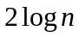 height>
The search, insertion, and deletion times in a red-black tree depend on the height of the tree. A red-black tree corresponds to a 2-4 tree. When you convert a node in a 2-4 tree to red-black tree nodes, you get one black node and zero, one, or two red nodes as its children, depending on whether the original node is a 2-node, 3-node, or 4-node. So, the height of a red-black tree is at most as twice that of its corresponding 2-4 tree. Since the height of a 2-4 tree is 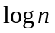, the height of a red-black tree is .

<margin note: red-black vs. AVL>
A red-black tree has the same time complexity as an AVL tree, as shown in Table 48.1. In general, a red-black is more efficient than an AVL tree, because a red-black tree requires only one time restructuring of the nodes for insert and delete operations.

<margin note: red-black vs. 2-4>
A red-black tree has the same time complexity as a 2-4 tree, as shown in Table 48.1. In general, a red-black is more efficient than a 2-4 tree for two reasons:
- A red-black tree requires only one-time restructuring of the nodes for insert and delete operations. However, a 2-4 tree may require many splits for an insert operation and fusion for a delete operation.
- A red-black tree is a binary search tree. A binary tree can be implemented more space efficiently than a 2-4 tree, because a node in a 2-4 tree has at most three elements and four children. Space is wasted for 2-nodes and 3-nodes in a 2-4 tree.

Table 48.1
Time Complexities for Methods in RBTree, AVLTree, and Tree234
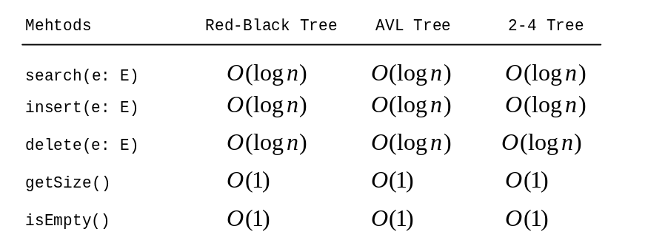
Listing 48.5 gives an empirical test of the performance of AVL trees, 2-4 trees, and red-black trees.

Listing 48.5 TreePerformanceTest.java

<margin note line 6: an AVL tree>
<margin note line 11: a 2-4 tree>
<margin note line 16: a red-black tree>
<margin note line 21: start time>
<margin note line 29: shuffle>
<margin note line 33: add to tree>
<margin note line 35: shuffle>
<margin note line 39: remove from container>
<margin note line 41: end time>
<margin note line 42: return elapsed time>
public class TreePerformanceTest {
public static void main(String[] args) {
final int TEST_SIZE = 500000; // Tree size used in the test

// Create an AVL tree
Tree<Integer> tree1 = new AVLTree<Integer>();
System.out.println("AVL tree time: " +
getTime(tree1, TEST_SIZE) + " milliseconds");

// Create a 2-4 tree
Tree<Integer> tree2 = new Tree24<Integer>();
System.out.println("2-4 tree time: "
+ getTime(tree2, TEST_SIZE) + " milliseconds");

// Create a red-black tree
Tree<Integer> tree3 = new RBTree<Integer>();
System.out.println("RB tree time: "
+ getTime(tree3, TEST_SIZE) + " milliseconds");
}

public static long getTime(Tree<Integer> tree, int testSize) {
long startTime = System.currentTimeMillis(); // Start time

// Create a list to store distinct integers
java.util.List<Integer> list = new java.util.ArrayList<Integer>();
for (int i = 0; i < testSize; i++)
list.add(i);

java.util.Collections.shuffle(list); // Shuffle the list

// Insert elements in the list to the tree
for (int i = 0; i < testSize; i++)
tree.insert(list.get(i));

java.util.Collections.shuffle(list); // Shuffle the list

// Delete elements in the list from the tree
for (int i = 0; i < testSize; i++)
tree.delete(list.get(i));

// Return elapse time
return System.currentTimeMillis() - startTime;
}
}
<Output>
AVL tree time: 7609 milliseconds
2-4 tree time: 8594 milliseconds
RB tree time: 5515 milliseconds
<End Output>

The getTestTime method creates a list of distinct integers from 0 to testSize – 1 (lines 25–27), shuffles the list (line 29), adds the elements from the list to a tree (lines 32–33), shuffles the list again (line 35), removes the elements from the tree (lines 38–39), and finally returns the execution time (line 42).

The program creates an AVL (line 6), a 2-4 tree (line 11), and a red-black tree (line 16). The program obtains the execution time for adding and removing 500000 elements in the three trees.

<margin note: red-black tree best>
As you see, the red-black tree performs the best, followed by the AVL tree.

NOTE:
<margin note: java.util.TreeSet>
The java.util.TreeSet class in the Java API is implemented using a red-black tree. Each entry in the set is stored in the tree. Since the search, insert, and delete methods in a red-black tree take 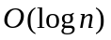 time, the get, add, remove, and contains methods in java.util.TreeSet take time.

NOTE:
<margin note: java.util.TreeMap>
The java.util.TreeMap class in the Java API is implemented using a red-black tree. Each entry in the map is stored in the tree. The order of the entries is determined by their keys. Since the search, insert, and delete methods in a red-black tree take time, the get, put, remove, and containsKey methods in java.util.TreeMap take time.

Key Terms

- black depth
- double-black violation
- double-red violation
- external node
- red-black tree

Chapter Summary

- A red-black tree is a binary search tree, derived from a 2-4 tree. A red-black tree corresponds to a 2-4 tree. You can convert a red-black tree to a 2-4 tree or vice versa.
- In a red-black tree, each node is colored red or black. The root is always black. Two adjacent nodes cannot be both red. All external nodes have the same black depth.
- Since a red-black tree is a binary search tree, the RBTree class extends the BinaryTree class.
- Searching an element in a red-black tree is the same as in binary search tree, since a red-black tree is a binary search tree.
- A new element is always inserted as a leaf node. If the new node is the root, color it black. Otherwise, color it red. If the parent of the new node is red, we have to fix the double-red violation by reassigning the color and/or restructuring the tree.
- If a node to be deleted is internal, find the rightmost node in its left subtree. Replace the element in the node with the element in the rightmost node. Delete the rightmost node.
- If the external node to be deleted is red, simply reconnect the parent node of the external node with the child node of the external node.
- If the external node to be deleted is black, you need to consider several cases to ensure that black height for external nodes in the tree is maintained correctly.
- The height of a red-black tree is O(logn). So, the time complexities for the search, insert, and delete methods are O(logn).

Test Questions
Do the test questions for this chapter online at www.cs.armstrong.edu/liang/intro9e/test.html.

Review Questions

Sections 48.1–48.2
48.1
What is a red-black tree? What is an external node? What is black-depth?

48.2
Describe the properties of a red-black tree.

48.3
How do you convert a red-black tree to a 2-4 tree? Is the conversion unique?

48.4
How do you convert a 2-4 tree to a red-black tree? Is the conversion unique?

Sections 48.3–48.5
48.5
What are the data fields in RBTreeNode?

48.6
How do you insert an element into a red-black tree and how do you fix the double-red violation?

48.7
How do you delete an element from a red-black tree and how do you fix the double-black problem?

48.8
Show the change of the tree when inserting 1, 2, 3, 4, 10, 9, 7, 5, 8, 6 into it, in this order.

48.9
For the tree built in the preceding question, show the change of the tree after deleting 1, 2, 3, 4, 10, 9, 7, 5, 8, 6 from it in this order.

Programming Exercises

48.1*
(red-black tree to 2-4 tree) Write a program that converts a red-black tree to a 2-4 tree.

48.2*
(2-4 tree to red-black tree) Write a program that converts a red-black tree to a 2-4 tree.

48.3***
(red-black tree animation) Write a Java applet that animates the red-black tree insert, delete, and search methods, as shown in Figure 48.6.

48.4**
(Parent reference for RBTree) Suppose that the TreeNode class defined in BinaryTree contains a reference to the node’s parent, as shown in Exercise 26.17. Implement the RBTree class to support this change. Write a test program that adds numbers 1, 2, ..., 100 to the tree and displays the paths for all leaf nodes.

